COVERING SHEET – INSTRUCTIONS

THIS COVERING SHEET MUST BE REMOVED BEFORE SENDING EASY READ QUESTIONNAIRE TO MATERNITY SERVICE USER.

The availability of the Easy Read questionnaire will be signposted on the mailing letters and multi-language sheet and administered at the request of the maternity service user.
When you receive a request for an Easy Read questionnaire, please take down the maternity service user's name and address and, if possible, the questionnaire’s barcode number.
Once requested, the following steps should be taken.
Administering the request:
- Any highlighted yellow text on the Easy Read questionnaire should be personalised.
- The questionnaire should also be personalised with the maternity service user survey number. This will enable any returns to be processed.
- The questionnaire should be posted to the maternity service user alongside a return envelope. You can either use the Freepost address you have set up or include a stamped addressed envelope to a different processing address.
- We are monitoring requests for Easy Read questionnaires separately for MAT24. Please log any Easy Read requests in the fieldwork monitoring spreadsheet.
- We recommend that maternity service users who request Easy Read questionnaires are logged as opt-out (outcome code 4). This will ensure they do not receive any further mailings. If the maternity service user then takes part in the survey, the code should be changed to complete (outcome code 1).
- At the time of the maternity service user requesting the Easy Read, if it is likely they will receive a further mailing (e.g. due to mailing deadlines) it is worth making them aware this will happen, but that an Easy Read will also be sent to them.
- If the maternity service user does not take part in the survey, the Easy Read request noted in the weekly monitoring spreadsheet should be left in and an outcome code 6 added.

Processing the return:
Manually enter responses into the excel data entry spreadsheet for Easy Read questionnaire responses.



Survey number: | [INSERT HERE]

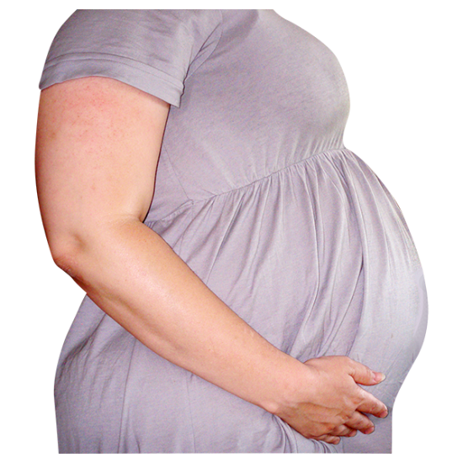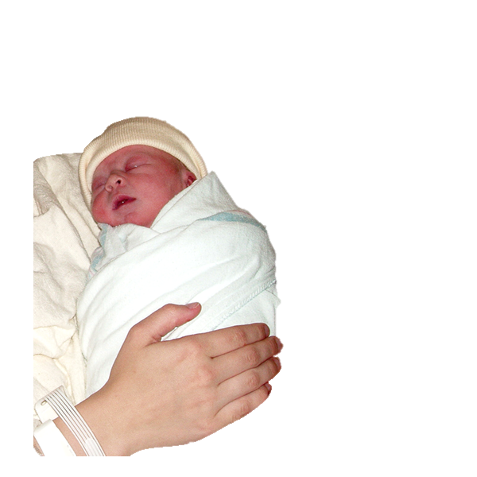

Please tell us about your maternity care at [name of trust]
2024

 | Easy read version of the Maternity Survey 2024
 |  | About this booklet
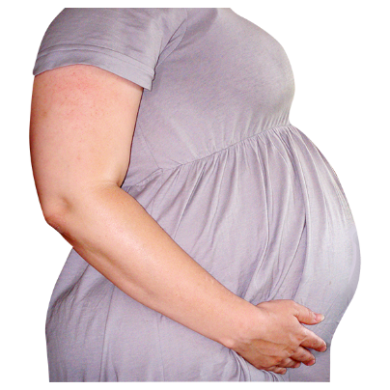 |  | We would like you to answer some questions about your maternity care.
 |  | Your answers will help improve maternity care.
 |  | You can answer each question by putting a tick in the box next to the answer you want.
 |  | You can ask somebody to help you read the questions and answer them if you want.
 |  | But they should not tell you which answer to pick, because we want to know what you think.
 |  | You do not have to answer all the questions if you do not want to.
  Private |  | Your answers are private. We will not use your name when we share what we have found out from all the answers we receive.

 | People
 | - Did you feel the midwives or doctors gave you the right care or treatment?
 | ☐ Yes
 | ☐ Sometimes

 | ☐ Not at all
 | ☐ I do not know or cannot remember

 |  | - Did the midwives or doctors help you make decisions about your care?
 |  | ☐ Yes
 |  | ☐ Sometimes
 |  | ☐ Not at all
 |  | ☐ I do not know or cannot remember
 | - Did the midwives or doctors treat you with respect?  Respect means that you accept somebody for who they are, even when they're different from you.
 | ☐ Yes
 | ☐ Sometimes
 | ☐ Not at all
 | ☐ I do not know or cannot remember

 | Communication  - Did the midwives or doctors help you understand information about your care?
 | ☐ Yes
 | ☐ Sometimes
 | ☐ Not at all
 | ☐ I did not need this
 | ☐ I do not know or cannot remember
 | - Did the midwives or doctors listen to what you had to say?
 | ☐ Yes
 | ☐ Sometimes
 | ☐ Not at all
 | ☐ I did not need this
 | ☐ I do not know or cannot remember
 | - During your care, you might have been in pain.  Caring  Were you able to get help for your pain when you needed it?
 | ☐ Yes
 | ☐ Sometimes
 | ☐ Not at all
 | ☐ I did not need this
 | ☐ I do not know or cannot remember

 | - During your care, you might have needed help quickly.  Were you able to get help when you needed it?

 | ☐ Yes
 | ☐ Sometimes
 | ☐ Not at all
 | ☐ I did not need this
 | ☐ I do not know or cannot remember
 | - Did the midwives or doctors help you feel comfortable to talk to them about your worries and fears?

☐ Yes

☐ Sometimes

☐ Not at all

☐ I did not need this

☐ I do not know or cannot remember

Feeding your baby
- Did you feel the midwives supported you with feeding your baby?

☐ Yes

☐ Sometimes

☐ Not at all

☐ I did not need this

☐ I do not know or cannot remember

 | Overall
 | - How do you feel about the care you  were given?
 | ☐ Happy
 | ☐ OK
 | ☐ Unhappy
 | ☐ I do not know or cannot remember

 |   About you  - How would you describe your gender?
 | ☐ Male
 | ☐ Female
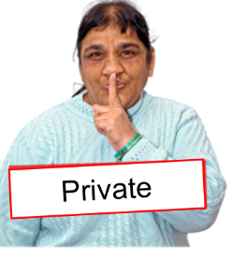 | ☐ I do not want to say
 | ☐ Other (please write down how you would describe yourself below)

   | 12. How old are you?  (Please write your age in years below.)
 | Anything else
 | 13. Would you like to tell us anything else about your maternity care?  Please write it below.

Thank you very much for answering these questions.


   | When we have looked at all the answers from everyone, we will write a report about what we found and put it on our website at: www.cqc.org.uk/surveys.  We will take out any information that could identify you before making your answer public. But the NHS trust and the people (like CQC) you send these answers to will see your full answer. If your answer needs looking into, we may share it with the best person to help.

 | What to do with your answers
   | Please post your answers back in the FREEPOST envelope provided. No stamp is needed.
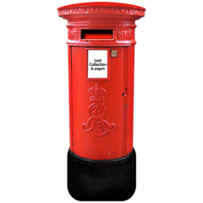 | If you do not have your FREEPOST envelope, please send your answers to <INSERT FREEPOST ADDRESS>

